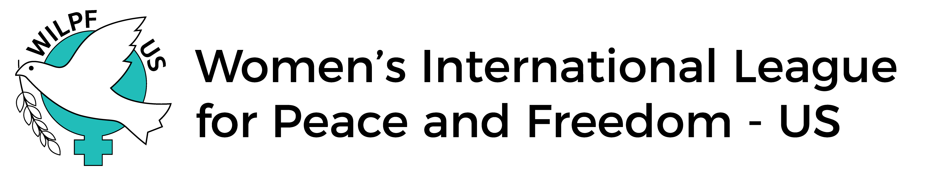
-Application for the Local to Global Program at the United Nations
Submission deadline: Friday, January 5, 2024. Submit all materials to ​
​ UN-L2G-mail@wilpfus.org
Please note: When listing your permanent address, please provide the address that corresponds with your license/passport. You will not be granted entrance into the UN unless the address on your license/passport matches the paperwork we submit to the UN. If your current mailing address is different from the address on your license/passport, please list your current mailing address below, so that you will be able to receive important materials prior to the Practicum.
This program is open to all WILPF US members in good standing with the national section and who are active in a branch and/or a national issue or standing committee.
NOTE: Local to Global participants are required to mentor participants in the WILPF US Practicum Program throughout the year following the CSW Forum to help foster relationships between Local to Global and Practicum participants that reach beyond the week of the CSW and help guide these new members, but also to work as a team to share what they learned at the Forum and about issues and topics within the feminist and women’s movement that are part of WILPF’s work. WILPF’s CSW Program Coordinators will work with Local to Global participants to pair them with Practicum participants based on proximity to their branch or similarity of activism/advocacy interests. Local to Global participants will be required to attend an additional meeting with the Practicum Coordinator during the week of CSW to discuss mentorship roles and responsibilities.

Local to Global participants are also required to complete a project of their own design – generally, a public or WILPF presentation of some kind, related to the CSW programs, and, where possible, linked to WILPF projects near you. You will be asked to discuss the parameters of this project with our program coordinator for encouragement and advise.
Special Consideration: Due​ to the nature of discussions with participants in the concurrent Practicum program, and the freedoms we allow them in sharing their personal views, their questions which we address, and individual expression, we ask that Local to Global applicants holding academic positions not apply during the same program year as their student who is applying for the concurrent Practicum program – specifically a student whom they are currently grading, supporting as a faculty advisor, or evaluating on an academic committee.

FUNDING INFORMATION
Substantial funding subsidies are provided for qualifying current WILPF members participating as part of the Local to Global program to attend the Commission on the Status of Women.
Name (chosen/preferred):
Gender: Race/ethnicity:
Pronouns (she/her/hers; he/him/his; they/them/theirs; etc.):
Permanent address, listed on your passport/license:

Current mailing address:

Telephone (cell):
Email:
Date of birth:
Local WILPF branch (or state “At-Large” if you have no branch) and/or issues committee membership:
Branch or issues committee reference name, telephone, and email:
Disabilities (please specify accommodations needed):
Dietary Requests:
Housing preferences (participants are designated a roommate – are you comfortable rooming with someone of a different gender identity and/or sexual orientation than you? ​ Yes____ No____
(Your response will not affect your application).

Short Essays
In an attached document, answer the following questions (1 paragraph each):
- Why do you want to attend the Commission on the Status of Women meetings at the United Nations?
- How will you share your United Nations experience with your local WILPF branch, issue committee, or other WILPF members and community members with respect to United Nations advocacy work?
- If you are not applying based on active branch membership, you also be an active member of one of WILPF’s national issue or standing committees. Which committee(s) are you an active member of? And are you – including for active branch members – interested in working with (another) one of the national issue or standing committees?
- Will you be available for the entire week’s program at the CSW (starting the Saturday immediately prior to the Monday start of the CSW, through the Friday (all day) activities of this first week of the CSW? (Yes or no answer. If necessary, provide a brief explanation.)
- What experience have you had in mentoring other activists/advocates? What do you think are the best ways for WILPF US to engage people in our work?
- We will be staying within walking distance to the United Nations and other event locations. Participants are expected to manage most of their daily schedule to participate and arrive to events on time. Will you be able to walk or otherwise travel about two miles daily?

Branch or Issue/Standing Committee RECOMMENDATION
Have one branch, standing, or issue committee member who has known you for at least two years and knows your work in that body fill out the recommendation form and email it back to us at: UN-L2G-mail@wilpfus.org with the subject​:​ (Your first and last name) recommendation. Please advise your recommender that the recommendation form and letter is due no later than Monday, January 8, 2024.

If selected to participate in Local to Global program, you are required to​ give our Local to Global Coordinator (UN-L2G-mail@wilpfus.org) NOTICE of​ cancellation as soon as possible but NO LESS THAN 48 HOURS before the Saturday, 10:30 am EST start of the program. Otherwise, you will be expected to reimburse WILPF US for any financial loss incurred due to your cancellation.
The working language of the WILPF US UN Programs is English.

