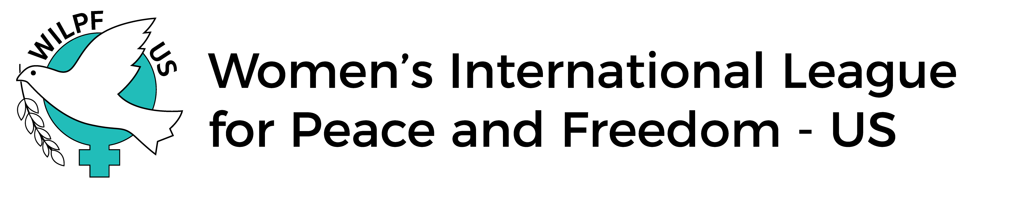
Application for the Practicum in Advocacy at the United Nations
Submission deadline: Monday, January 8th, 2024,​ at 11:59 PM PST​
Submit all materials to ​ ​practicum-mail@wilpfus.org

Please note: When​ listing your permanent address, please provide the address that corresponds with your license/passport. You will not be granted entrance into the UN unless the address on your license/passport matches the paperwork we submit to the UN. If your current mailing address is different from the address on your license/passport, please list your current mailing address below, so that you will be able to receive important materials prior to the Practicum.
Name (chosen/preferred)
Gender Race/ethnicity
Pronouns (she/her/hers; he/him/his; they/them/theirs; etc.)
Which college/university do you attend? Or Which Organization are you working for?

If currently enrolled in college or University, what is/are your major(s)?

If Graduate students: What is/are your field(s) of study and specialization(s)?

If not enrolled in any formal study program, then please state what are your specific areas of interest?

What areas of service or political work interests you? Are you currently engaged in that work, or will you be seeking work in that area?

Permanent address

Current mailing address

Telephone (cell)
Email
On March 8th 2024, how old will you be?
Name and contact information of faculty sponsor (if applicable) (Address, email, phone)
What accommodation do you need for disabilities?

Dietary Requests
Housing preferences (students are designated a roommate – are you comfortable rooming with someone of a different gender identity and/or sexual orientation than you? ​ Yes____ No____
(Your response will not affect your application​).
The Practicum is a week-long commitment. You should plan to arrive at our hotel in New York City by late morning Sat of the March 9th 24 th and depart Sat. morning, March 16th 24. Will you be available for the entire week? Yes ____ No_____
I understand that designing and completing a public project is a requirement of this program. If I am accepted, I will commit to completing this project. Yes ____ No_____
As a Practicum participant, you are required to complete a project of your design, linked to WILPF US principles and programs, and, where possible, linked to WILPF projects near you, after you return from the CSW meetings. You will discuss the parameters of this project with our program faculty before and during the Practicum. Practicum faculty will help you design and carry out your project. Throughout the year, you will be providing Practicum faculty updates on your project. If, in addition, you intend to take on a project for college/university credits, Practicum faculty will work with you and your faculty advisor to ensure the project fits, is doable, and meets your institution’s requirements.

Short Essays Write essays separately and attach to your application.
- Explain why you would like to attend the WILPF Practicum this year. Discuss why the topics addressed in this year’s CSW program are important to you and which interests (personal, political, career) and perspectives you would contribute to the week-long practicum. (400-500 words) (You can find a description of the program at: https://www.unwomen.org/en/csw/csw68-2024.)
- Which interests of yours overlap with the goals and programs of the Women’s International League for Peace and Freedom? (200 – 300 words) (Information on US WILPF: https://wilpfus.org/)
- In the year that follows your participation, are you able to commit to making public presentations and/or writing about the content and experience of the Practicum? Are you able to commit to sharing the content and experience of the Practicum in the year that follows your participation? Yes____ No_____
If yes, describe two ways you plan to share your learnings in your community.
- Describe two ideas you have for your Practicum project. (150-200 words)

FUNDING INFORMATION (Please fill in the chart below)​
Please Note: The chart below is designed to help you plan your financing for attending the Practicum at the CSW. The cost for the Practicum is anticipated to be under $1000 for each participant. All students are expected to request funding from their university or institution with the assistance of a faculty sponsor and provide documentation of any contributions you receive. You may also solicit assistance from a local WILPF branch, if there is one in your area, or from other organizations who support WILPF’s goals. If you will need some financial assistance, please provide the monetary amount in the “scholarship funds requested” box. While scholarship monies are available, they are very limited. Please do​ not request the full amount of tuition on scholarship funding. Scholarship requests will be reviewed, and all applicants will receive a letter, upon acceptance to the Practicum, which details any award money and balance of funds due.

Scholarship funds requested ​(Note: Scholarships will fund only a portion of the cost) | $
Personal funds you can contribute | $
Funding provided by college or university | $
Funds you raise | $

Nondiscrimination statement: Our selection process does not discriminate on the basis of race, color, national or ethnic origin, citizenship, ancestry, age, religion or spiritual creed, disability or handicap, pregnancy, gender identity and/or expression, sexual orientation, military or veteran status, genetic information, or any other characteristic protected under applicable federal, state or local laws. The working language of the WILPF US UN Programs is English.

