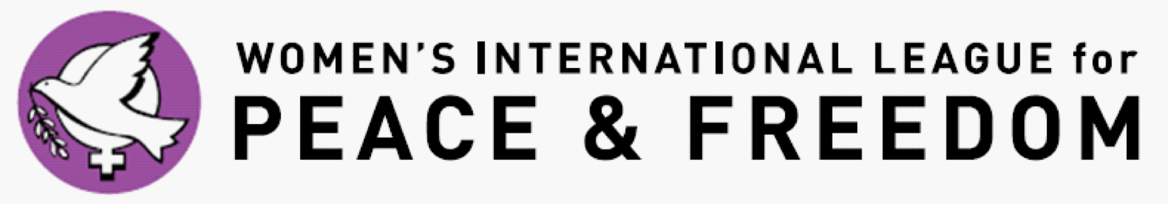

Application for the Practicum in Advocacy at the United Nations
Submission deadline: November 19, 2017 at 11:59 PM PST
Submit all materials to practicum-mail@wilpfus.org

Please note: When listing your permanent address, please provide the address that corresponds with your license/passport. You will not be granted entrance into the UN unless the address on your license/passport matches the paperwork we submit to the UN. If your current mailing address is different from the address on your license/passport, please list your current mailing address below, so that you will be able to receive important materials prior to the Practicum.
Alumni Applicants Only: Please identify an active WILPF member, Issue Committee Chair, Board Member or WILPF US leader who will serve as a reference and possible mentor. You will be asked to provide their contact information below.
Name (chosen/preferred):
Gender:
Pronouns (she/her/hers; he/him/his; they/them/theirs; etc.):
Are you a New Applicant or Alumni Applicant?
For New Applicants- List your college or university:
For Alumni Applicants- List your current institution or Job Title:
Permanent Address:

Current Mailing Address:

Telephone (cell):
E-Mail:
Date of birth:
New Applicant-Major or degree program (if declared):
Alumni Applicant-Degree or Current Job Field:
Level of School: (i.e. Undergrad junior, 1st year Master’s program)
New Applicant-Faculty Sponsor:
Alumni Applicant-Briefly explain your work with WILPF International, WILPF US, or a local WILPF Branch since participating in the Practicum initially. If you have not been involved since participating in the Practicum, please identify any Issue Committees, and/or work you plan to do or would like to do within WILPF:
New Applicant-Faculty Sponsor Telephone:
Alumni Applicant-Identified WILPF Reference Telephone:
New Applicant-Faculty Email:
Alumni Applicant-Identified WILPF Reference Email:
Disabilities (please specify accommodations needed):
Dietary Requests:
Housing Preferences (students are designated a roommate – are you comfortable rooming with an individual of a different gender identity/sexual orientation than you? Your response will not affect your application):
Short Essays
- In 500 words or less, please tell us why you would like to attend the Practicum this year. In your discussion, please consider addressing the following: why this year’s thematic material is important to you and what unique experiences and/or perspective you would bring to the opportunity.
  - (This year’s theme is “Challenges and opportunities in achieving gender equality and the empowerment of rural women and girls.”)
- Why are you interested in working with the Women's International League for Peace and Freedom? (Essay not to exceed 150 words.)
- Will you commit to helping publicize the content and experience of the Practicum in the year that follows the Practicum? (Please provide a yes or no answer. If necessary, provide a brief explanation.)
- Will you be available for the entire week's delegation? (Please provide a yes or no answer. If necessary, provide a brief explanation.)
- All Practicum participants will be required to complete a project of their design after the Commission on the Status of Women. The parameters of this project will be discussed in-depth throughout the week and students will be supported by Practicum faculty in the completion of this project. Faculty Advisors will be updated on the student’s progress and completion of this project.
  - I understand that this is a requirement of the program, commit to the project, and consent to Practicum faculty sending an update to my faculty advisor on the progress and completion of my project.
    - Yes
    - No
FACULTY RECOMMENDATION-New Applicants ONLY
Have one faculty member who knows you well and who can help you request funding from your institution fill out the form and email it back to us at practicum-mail@wilpfus.org with the subject: (your first and last name) recommendation. Please note that this form is due no later than November 19, 2017 at 11:59 PM PST. Without it, your application will not be considered.

FUNDING INFORMATION (Please fill in the chart below)
Please Note: This chart is designed to help you organize your finances for the Practicum at the CSW. The cost for the Practicum is $1,400 for each participant. All students are expected to request funding from their university or institution with the assistance of their faculty sponsor and provide proof of any contribution to Practicum Faculty. If you are in need of some financial assistance, please provide the monetary amount in the “scholarship funds requested” box. While scholarship monies are available, they are very limited. Please do not request the full amount of tuition on scholarship funding. Scholarship requests will go through a reviewing process and all applicants will receive a letter, upon acceptance to the Practicum, which details any award money and/or balances due.

Scholarship funds requested: (Please do not request the entire tuition amount) | $ .
Personal funds contributed: | $ .
Funding provided by university or institution: (New Applicants ONLY) | $ .
Funds raised by applicant: | $ .

Nondiscrimination statement: The selection process for the UN Practicum in Advocacy Program of WILPF US requires that you be currently enrolled in a Bachelor’s, Master’s, or Doctoral program. It does not discriminate on the basis of race, color, national or ethnic origin, citizenship, ancestry, age, religion or spiritual creed, disability or handicap, sex, pregnancy, gender identity and/or expression, sexual orientation, military or veteran status, genetic information, or any other characteristic protected under applicable federal, state or local laws. Retaliation is also prohibited. The working language of the WILPF U.S. UN Programs is English.

