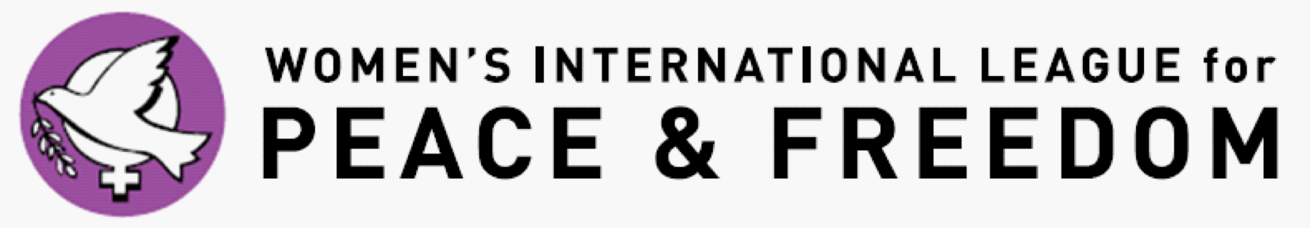

Application for the Local2Global Program at the United Nations
Submission deadline: November 19, 2017 at 11:59 PM PST
Submit all materials to practicum-mail@wilpfus.org
Please note: When listing your permanent address, please provide the address that corresponds with your license/passport. You will not be granted entrance into the UN unless the address on your license/passport matches the paperwork we submit to the UN. If your current mailing address is different from the address on your license/passport, please list your current mailing address below, so that you will be able to receive important materials prior to the Practicum.
Special Consideration: Due to the nature of discussions with students in the concurrent Practicum program, and the freedoms we allow them in sharing their personal views, their questions which we address, and individual expression, we ask that L2G applicants holding academic positions not apply during the same program year as their student who is applying for the concurrent Practicum program - specifically a student with whom they are currently grading, supporting as a faculty advisor, or sitting on an academic committee.
This program is open to all WILPF US members in good standing with the national section. If you have questions about your status with the national section, please contact practicum-mail@wilpfus.org.
Name (chosen/preferred):
Gender:
Pronouns (she/her/hers; he/him/his; they/them/theirs; etc.):
Permanent Address:

Current Mailing Address:

Telephone (cell):
E-Mail:
Date of Birth:
Local WILPF Branch (or state “At-Large” if you have no Branch) or Issues Committee Membership:
Branch or Issues Committee Reference Name & Telephone:
Branch or Issues Committee Reference Name & Email:
Disabilities (please specify accommodations needed):

Dietary Requests:

Housing Preferences (participants are designated a roommate – are you comfortable rooming with an individual of a different gender identity/sexual orientation than you?):
Short Essays
On an attached document, please answer the following questions:
1.) Why do you want to attend the 2018 Commission on the Status of Women meetings at the United Nations?
2.) What are your plans for sharing your United Nations experience with your local WILPF branch or Issues Committee and community members in United Nations advocacy work?
3.) If you are applying as a Branch member, are you also a member of one of WILPF’s national Issues Committees? Would you like to work with one of the national Issues Committees?
4.) Will you be available for the entire week’s delegation to the CSW (starting Saturday afternoon prior to the Monday start of the CSW, through the Friday (all day) activities of this first week of the CSW? (Please provide a yes or no to answer this question. If necessary, provide a brief explanation.)
Branch or Issues Committee RECOMMENDATION
Have one branch or issues committee member who knows you well fill out the recommendation form and email it back to us at practicum-mail@wilpfus.org with the subject: Your first and last name recommendation. Please note that this form is due no later than November 19 at 11:59 PM PST. Without it, your application will not be considered.

FUNDING INFORMATION (Please fill in the chart below)
Funding is available for current WILPF members in good standing participating as part of the Local2Global program to attend the Commission on the Status of Women. If selected to be a delegate you are required to give the UN Programs Coordinator (practicum-mail@wilpfus.org) no less than 48 hours’ notice of cancellation or you will be expected to reimburse WILPF US for any financial loss incurred due to your cancellation.

Nondiscrimination statement: The selection process for the UN Practicum in Advocacy Program of WILPF US requires that you be currently enrolled in a Bachelor’s, Master’s, or Doctoral program. It does not discriminate on the basis of race, color, national or ethnic origin, citizenship, ancestry, age, religion or spiritual creed, disability or handicap, sex, pregnancy, gender identity and/or expression, sexual orientation, military or veteran status, genetic information, or any other characteristic protected under applicable federal, state or local laws. Retaliation is also prohibited. The working language of the WILPF U.S. UN Programs is English.

